**Unmanned Aerial System Control using Gyroscope in Mobile Devices**

A Research Paper

Presented to:

**Engr. Julius Jr. V. Olandria**

Adviser in ECE 170 - System Design/Capstone Project 1

In partial fulfillment of the Requirements

In ECE 170 - System Design/Capstone Project 1

Necesito, Michael John T.

Orcullo, Carl Jev F.

JULY 12, 2021

# **Chapter 1**

## **1.1 Background of the Study**

With the emergence of advanced technology, people have become creative as to which technological advancement should be done next. People eventually went to improve some aspects of technology. For instance, the creation of aerial vehicles such as airplanes and helicopters opened a new idea for inventors to create a more systematic aerial vehicle that can be controlled from afar and will not require pilots. Thus, the idea of unmanned aerial vehicles comes to place.

Drones are also called Unmanned Aerial Vehicles (UAV) or Unmanned Aerial Systems (UAS) and, as their name implies, are aircrafts that can fly without the aid of a pilot and passengers. Instead, drones are controlled either by controlling them remotely via radio waves or using a predetermined route programmed within the UAV themselves [1].

Drones were originally used for enemy spying during WWI. They're little radio-controlled planes that may be used to capture photographs. Their usage has now spread to civilian hobbyists and is rapidly growing into several fields like in agriculture [2]. In a wide number of fields, drone technology offers great benefits and prospects. Drones help in surveying, humanitarian assistance, disaster risk management, research, and transportation, among other things [3].

This study focuses on making a drone connected to an Android device via a Bluetooth module, and is controlled by the user using the Android device’s microelectromechanical systems (MEMS) gyroscope and accelerometer.

Microelectromechanical systems (MEMS), also written as micro-electro-mechanical systems,

Bluetooth, according to [4], is defined as a low cost, low power, short range radio technology whose original purpose was to replace wired cables in connecting devices. In 2010, Bluetooth 4.0 was released—also called Bluetooth Low Energy (BLE). As defined by [5], BLE supports a hub-and-spoke model of connectivity. That is, one device being a central hub—or simply the “Central”—while other devices connected to it are dubbed “Peripherals”.

## **1.2 Statement of the Problem**

The main underlying issue of the project is connecting an Android phone to a drone equipped with a Bluetooth module. Specifically, the problem that the researchers will try to solve mainly revolves in transmitting an Android phone’s real-time gyroscope and accelerometer data to a drone, allowing it to hover based on the data it received.

## **1.3 Objectives**

The researchers aim:

### **1.3.1 General Objective(s):**

1. To develop a drone that can be controlled using an Android phone’s real-time gyroscope and accelerometer data.

### **1.3.2 Specific Objective(s):**

1. To create an X-frame drone equipped with a Bluetooth module.
2. To connect the Android device to the drone.
3. To get the Android device’s gyroscope and accelerometer data.
4. To transmit the data to the drone.
5. To move the drone based on the data transmitted.

## **1.4 Significance of the Study**

The study will benefit the following:

1. **Drone Enthusiasts** - This new innovation in drone control will make the drone enthusiasts explore new possibilities. Having a switch of controls from the typical joystick controller will revolutionize future drone controls.
2. **Mobile Phone Companies** - Phone companies can include this type of drone control system to their devices.
3. **Mobile Application Developers** - The application can provide information to the app developers on how to utilize the sensors built in the mobile device itself, especially the gyroscope.
4. **Technological Advancements** - The change in drone control can be a progress in technology especially in drone controls.
5. **Future Researchers** - Future scholars can utilize the information acquired in this study as a reference in their own research, and it can be improved.

## **1.5 Scope and Delimitation**

### **1.5.1 Scope**

The Android device used is Oppo A92 and the range for the drone controlled is between 2-3 meters away from the user.

### **1.5.2 Delimitation**

The paper will not discuss thoroughly the specifics of gyroscopes, Bluetooth LE, and the hardware used to build the robot. Finally, the researchers will be using Blynk as a medium to establish a connection between the Android device and the drone.

## **1.6 Definition of Terms**

The following are the terms mostly used in the study:

**Unmanned Aerial Vehicle (UAV)** - also known as drone, is an aircraft that does not require an onboard pilot [6].

**Micro-electro-mechanical systems (MEMS) gyroscope -** Gyroscopes, or gyros, are devices that measure or maintain rotational motion. MEMS (microelectromechanical system) gyroscopes are small, inexpensive sensors that measure angular velocity [7].

**Accelerometer -** Accelerometers, in mobile phones, are used to detect the orientation of the phone [8].

**Bluetooth -** Bluetooth is defined as a low cost, low power, short range radio technology whose original purpose was to replace wired cables in connecting devices [4].

# **Chapter 2**

## **Related Literatures and Studies**

**2.1 Drones**

**2.1.1 Definition**

By general definition, a drone is defined by any vehicle—air, land, or sea—without any human crew aboard it. Moreover, [9] further described that these vehicles are controlled either remotely or automatically. In the former, drones are manually controlled by human operators from a distance while the latter describe drones that are controlled by robotics means.

The main drone types are enumerated as fixed-wing systems and multirotor systems by [10]. Fixed-wing systems, by definition, are drones with fixed static wings. Multirotor systems, on the other hand, uses propellers to generate lift. [10] also defined a tertiary drone type, “other systems”, and is generally used to label drones that does not fall into either system, or a hybrid of both systems.

In [1], drones are comprised of two major systems—its movement system and its control system. The former major system is expanded into its frame, propellers and engine, and the drone’s power. Generally, a drone’s frames should be light and is based on the number of that drone’s propeller and engines. The same article categorized drones, specifically multirotor drones, into its possible frame constructions with propellers at the end of each arm [1].

Figure 2.1.1 Drones as Categorized by its Frame Construction

In quadcopter drones, two of its propellers rotate clockwise while the remaining two propellers rotate counterclockwise. This results into the drone hovering from its position [10].

**2.1.2 Functions and Applications**

Drones can be equipped with different types of payloads considering the drone has the capability to handle the attachment’s weight and size. Most commonly payloads equipped into drones are cameras and microphones [10].

[1] also tried to categorize drones with their functionality: civil drones and military drones. [12] added another type of drones with functionality focuses on commercial uses.

**2.2 Android Sensors**

Android documentation described motion sensors to be useful in monitoring device movement. The movement could either be a motion in relative to the device’s frame of reference or in relative to the world’s frame of reference. An example of the former case could be a game where the user controls their character by moving the device while an example of the later case could be the device sensing movement with the user inside the car [13].

Nagpal [14] explored Android sensors where he described sensors as “a device that measures a particular kind of quality”. Most sensors are Micro Electro Mechanical Sensors (MEMS)—sensors made on a tiny scale and measures a change in electrical signal in consequence of any forms of mechanical motion. Specified in the same book, motion sensors measure force that could potentially create any form of motion in the device’s x, y, and z axes. Table 2.2.1 summarizes Android motion sensors with their type, value, underlying sensors, description, usage, and power consumption.

**2.3 Bluetooth 4.0**

The rise of Bluetooth revolutionized the way people interact with technology around them [4]. Bluetooth Low Energy—or simply Bluetooth 4.0—has been designed by the Bluetooth Special Interest Group (SIG) and was optimized for a low cost, low power, and low complexity radio standard [15]. This enabled BLE to be a solution for efficient controlling and monitoring applications it is connected to, making it play a vital part in the emerging concept of Internet of Things (IoT) [16, 17].

Bluetooth Low Energy has a similar protocol stack to the classic Bluetooth and is presented in Figure 2.3.1 and is further defined in [4]. Furthermore, a BLE device can transmit data in a line-of-sight range (approximately 30 meters), although a more common operating range is within 2 to 5 meters [15].

Figure 2.3.1 BLE Protocol Stack

In fact, several studies [11, 18, 19] implemented Bluetooth Low Energy to communicate with their drones, as it was efficient and has a low cost compared to other means.

Table 2.2.1 Summary of Android Motion Sensors

# **Chapter 3**

## **Methodology**

## **3.1 Process Model**

The process model that will be used is the waterfall model. The waterfall model emphasizes the whole process of the study from the starting plans up to the implementation of the said study.

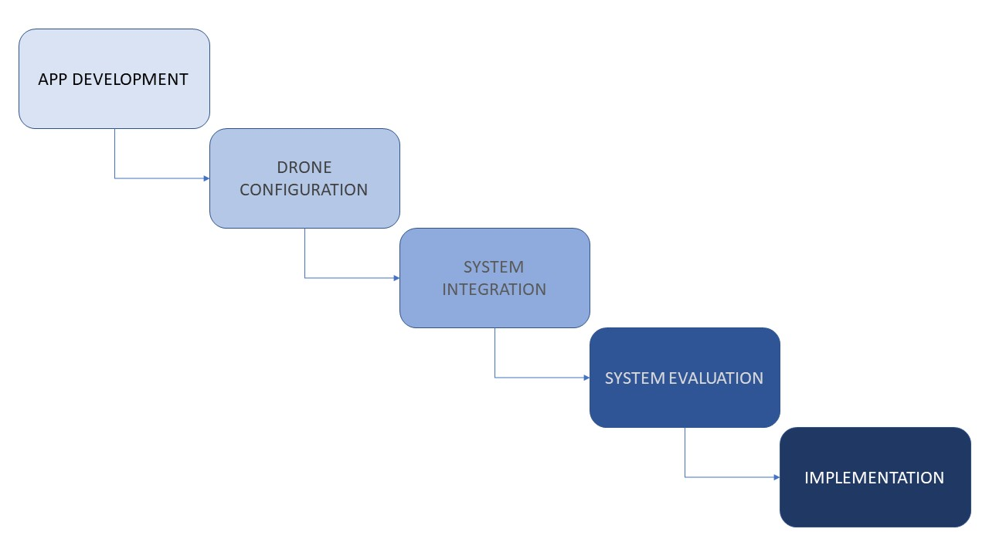Figure 3.1.1 The Process Model

## **3.2 Research Procedures**

The study will undergo five stages: App Development, Drone Configuration, System Integration, System Evaluation, and Implementation.

**3.2.1 App Development**

Giatay lods wala pa nako nahuman ang app pero semi human na man sya tas working na pero jusko unsaon nako to hahahahaha.

# **References**

[1] P. Kardasz, J. Doskocz, M. Hejduk, P. Wiejkut, en H. Zarzycki, “Drones and possibilities of their using”, *Journal of Civil & Environmental Engineering*, vol 6, no 3, bll 1–7, 2016.

[2] N. J. Stehr, “Drones: The newest technology for precision agriculture”, *Natural Sciences Education*, vol 44, no 1, bll 89–91, 2015.

[3] M. Ayamga, S. Akaba, en A. A. Nyaaba, “Multifaceted applicability of drones: A review”, *Technological Forecasting and Social Change*, vol 167, bl 120677, 2021.

[4] J. Bray en C. F. Sturman, *Bluetooth 1.1: connect without cables*. pearson Education, 2001.

[5] K. Townsend, C. Cufí, R. Davidson, en Others, *Getting started with Bluetooth low energy: tools and techniques for low-power networking*. “ O’Reilly Media, Inc.”, 2014.

[6] C. Li, X. Sun, en J. Cai, “Intelligent mobile drone system based on real-time object detection”, *Journal of Artificial Intelligence*, vol 1, no 1, bl 1, 2019. pp. 1-8

[7] *Gyroscope*. [Online]. Available: https://learn.sparkfun.com/tutorials/gyroscope/all. [Accessed: 06-Jan-2022].

[8] Gsmarena.com. 2022. *Sensors - definition - GSMArena.com*. [online] Available at: <https://www.gsmarena.com/glossary.php3?term=sensors> [Accessed 6 January 2022].

[9] G. Chamayou, A Theory of the Drone. New Press, The, 2015.

[10] D. B. Custers, “The Future of Drone Use—Opportunities and Threats From Ethical and Legal Perspectives—Asser. nl”. 2016.

[11] M. Masoud, Y. Jaradat, M. Farhoud, en A. Almdallaleh, “On Implementing a Low Cost Quadcopter Drone with Smartphone Control”, 2016.

[12] J. Irizarry, M. Gheisari, en B. N. Walker, “Usability assessment of drone technology as safety inspection tools”, Journal of Information Technology in Construction (ITcon), vol 17, no 12, bll 194–212, 2012.

[13] Android Developers, “Motion Sensors,” n.d. [Online]. Available: https://developer.android.com/guide/topics/sensors/sensors_motion. [Accessed 6 January 2022].

[14] V. Nagpal, Android Sensor Programming By Example. Packt Publishing Ltd, 2016.

[15] K. Townsend, C. Cufí, R. Davidson, en Others, Getting started with Bluetooth low energy: tools and techniques for low-power networking. “ O’Reilly Media, Inc.”, 2014.

[16] C. Gomez, J. Oller, en J. Paradells, “Overview and evaluation of bluetooth low energy: An emerging low-power wireless technology”, Sensors, vol 12, no 9, bll 11734–11753, 2012.

[17] P. Bulić, G. Kojek, en A. Biasizzo, “Data transmission efficiency in Bluetooth Low Energy versions”, Sensors, vol 19, no 17, bl 3746, 2019.

[18] A. B. J. Alemark en H. Bergkvist, “Quadcopter control using Android based sensing”, 2014.

[19] A. Kumar, R. Singh, U. Kumar, en A. Chaudhuri, “QUADROTOR FOR AGRO FARMING USING MPU-6050 AND BLUETOOTH MODULE”, 2019.